Flower Catalog Website

This is the landing page of the website.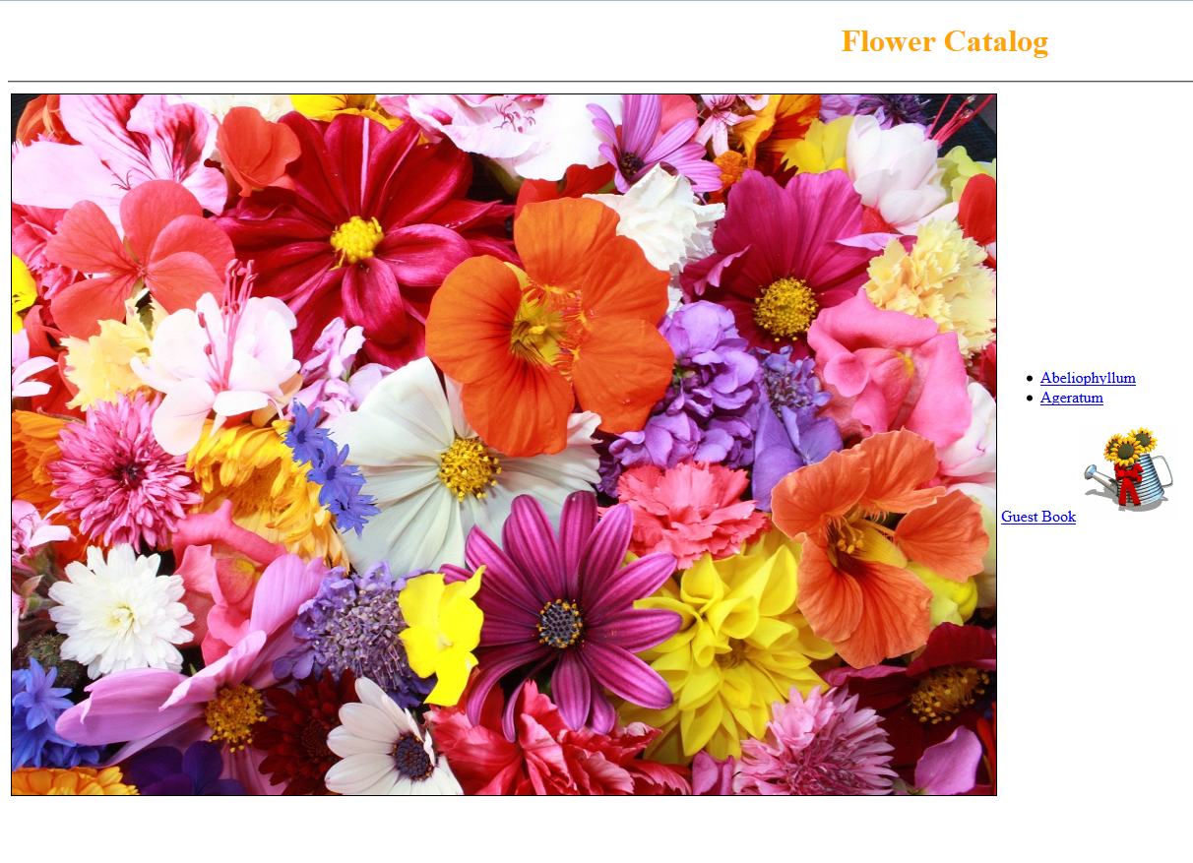

* Title “Flower Catalog” at the top.
* Image of flowers
* Links to pages of Abeliophyllum, Ageratum and a guest book.
* A watering Jar image, which when clicked will hide for a second(Not required to begin with)

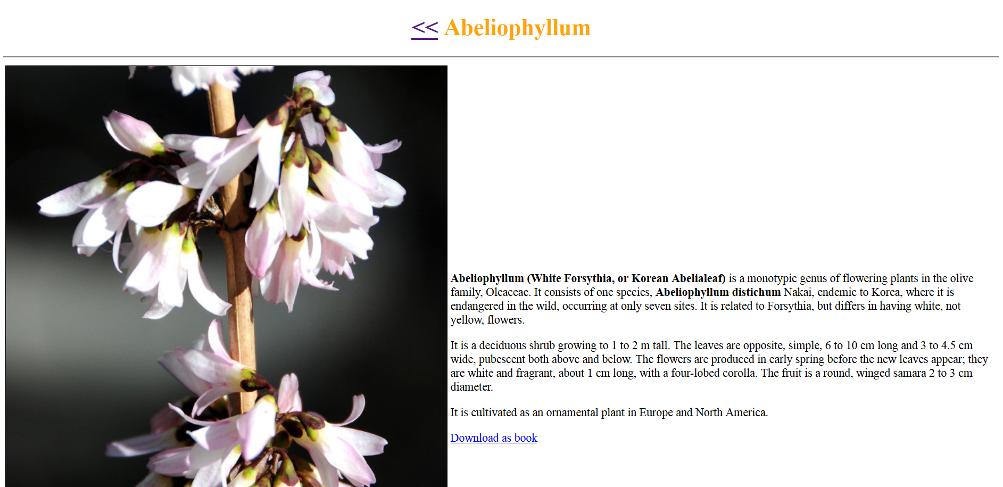

This is the page for Abeliophyllum.

* Image on left
* Centered title at top
* A link to go back to home page
* Formatted Content on the right of the image with information on the flower.
* A link to download the content as pdf.

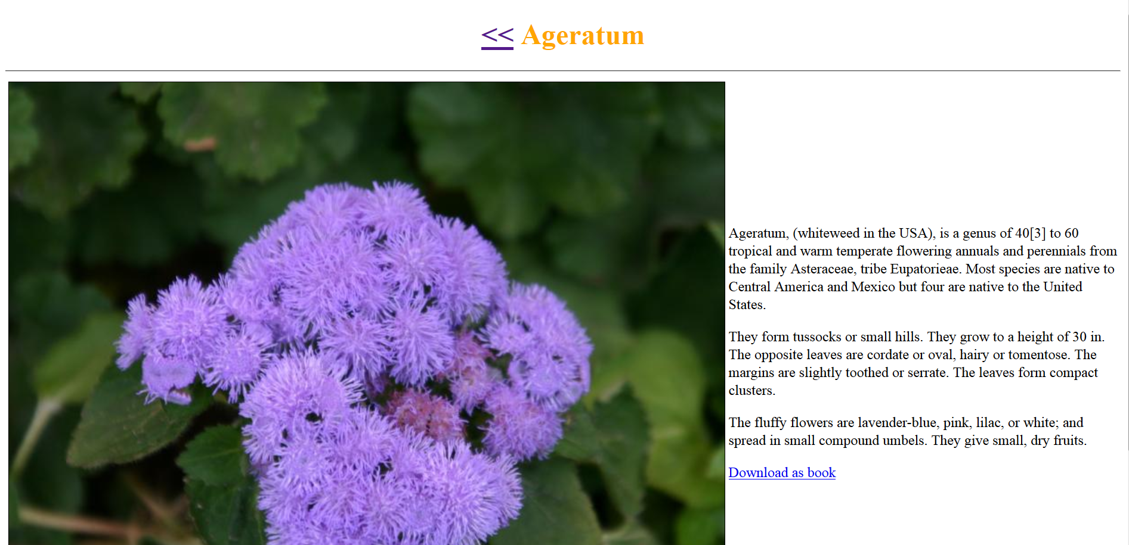

This is the page for Ageratum.

* Image on left
* Centered title at top
* A link to go back to home page
* Formatted Content on the right of the image with information on the flower.

A link to download the content as pdf.

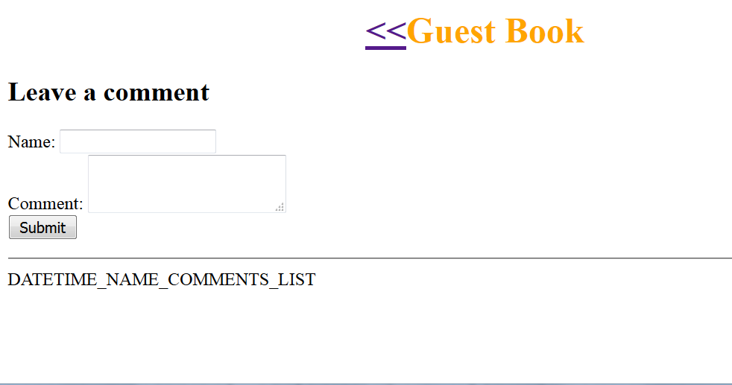

This is the page for Guest book.

* Centered title at top
* A link to go back to home page
* Text fields to take name & a comment.
* Submit button, which takes the comment
* A list of comments by different guest until now with Date-time, Name and Comment of each ordered with latest comment in reverse chronological order.